Knowledge Management

Case Study - IBM

 

UE17CS342

Project Guide:

Prof. Krupesha

Project Team:

Likith R Shekar PES1201700147

Sakshi Goel PES1201700148

Siddharth Shankar PES1201700691

Dinakar S M PES1201700857

Salman Ahmed PES1201700954

Pooja Patil PES1201701354

Table of Contents

1. Introduction (Rise of IBM)............................................................2
2. Business Model Canvas..............................................................5
3. Knowledge Management in IBM..................................................10
4. Other Key Knowledge Enablers...................................................11
5. Major Facts that led to the Downfall of IBM.................................14
6. Solutions IBM should have implemented.....................................17
7. IBM - Comeback..........................................................................18
8. Conclusion and References.........................................................20

Rise of IBM: A Brief History

The International Business Machines Corporation (IBM) is an American multinational technology company headquartered in Armonk, New York. It began in ***1911***, founded in Endicott, New York, as the ***Computing Tabulating Recording Company (CTR)*** and was renamed ***"International Business Machines"*** in ***1924***. Julius E. Pitrap patented the computing scale in 1885; Alexander Dey invented the dial recorder (1888); Herman Hollerith (1860–1929) patented the Electric Tabulating Machine and Willard Bundy invented a time clock to record a worker's arrival and departure time on a paper tape in 1889. On June 16, 1911, their four companies were amalgamated in New York State by Charles Ranlett Flint forming a fifth company, the Computing-Tabulating-Recording Company (CTR). They manufactured machinery for sale and lease, ranging from commercial scales and industrial time recorders, meat, and cheese slicers, to tabulators and punched cards. In 1914, Thomas J. Watson joined the CTR as a General manager and in 11 months became the President of the company.

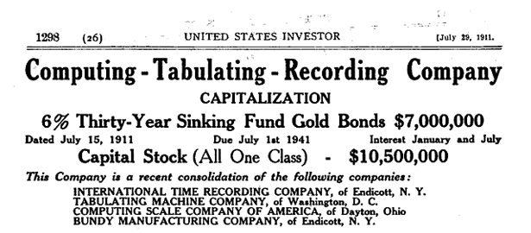

In 1937, IBM’s tabulating equipment enabled organizations to process huge amounts of data. The US government adopted the Social Security Act and made its first effort to maintain the employment records for about 26 million people using IBM’s punched card machines. The social security-related business gave an 81% increase in revenue from 1935 to 1939. In 1949 Thomas Watson, Sr., created IBM World Trade Corporation, a subsidiary of IBM focused on foreign operations. In 1957 the FORTRAN scientific programming language was developed. In 1944 IBM co-develops its first computer, the Automated Sequence Controlled Calculator aka Mark l, with Harvard University.

IBM developed its first commercial hard disk drive, the 350 RAMAC Disk Storage Unit, which was a major component of the groundbreaking 305 RAMAC computer.



*Automated Sequence Controlled Calculator*

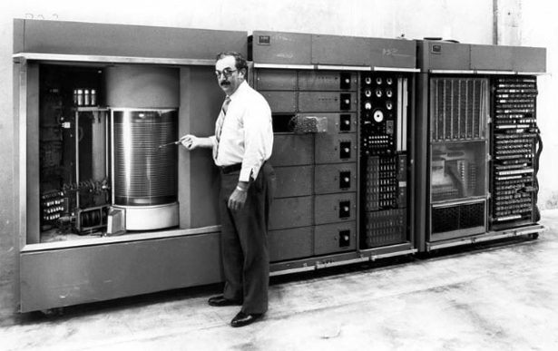

*350 RAMAC Disk Storage Unit*

On April 7, 1964, IBM announced the first computer system family, the IBM System/360. It spanned the complete range of commercial and scientific applications from large to small, allowing companies for the first time to upgrade to models with greater computing capability without having to rewrite their applications. It was followed by the IBM System/370 in 1970. In 1974 IBM engineer George J. Laurer developed the Universal Product Code. The IBM PC, originally designated IBM 5150, was introduced in 1981, and it soon became an industry standard. In 1991 IBM spun out its printer manufacturing into a new business called Lexmark.

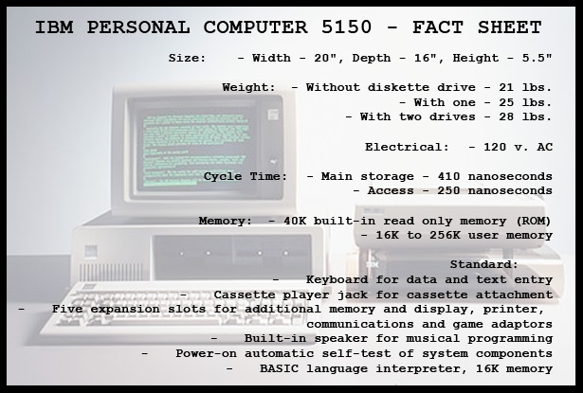

*IBM Personal Computer 5150 - Fact Sheet*

In 2005 the company sold its personal computer business to Chinese technology company Lenovo and, in 2009, it acquired software company SPSS Inc. Later in 2009, IBM's Blue Gene supercomputing program was awarded the National Medal of Technology and Innovation by U.S. President Barack Obama. In 2012 IBM announced it had agreed to buy Kenexa, and a year later it also acquired SoftLayer Technologies, a web hosting service, in a deal worth around $2 billion. In 2014 IBM announced it would sell its x86 server division to Lenovo for $2.1 billion. Also that year, IBM began announcing several major partnerships with other companies.

In 2015 IBM announced three major acquisitions: Merge Healthcare for $1 billion, data storage vendor Cleversafe, and all digital assets from The Weather Company, including Weather.com and the Weather Channel mobile app. In 2016, IBM acquired video conferencing service Ustream and formed a new cloud video unit. In 2015, IBM bought the digital part of The Weather Company; and in October 2018, IBM announced its intention to acquire Red Hat for $34 billion, which was completed on July 9, 2019.

Business Model Canvas

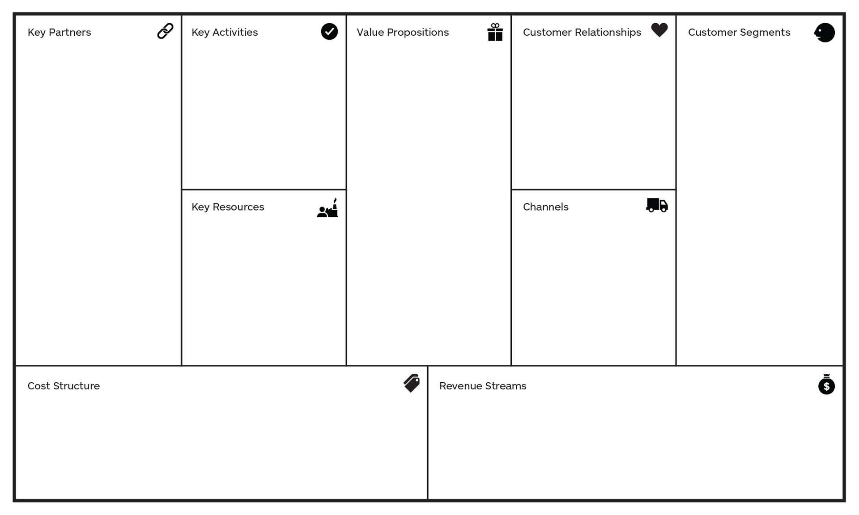

Template of a Business Model Canvas

**Value Proposition:** IBM never moves quickly but it always listens to its customers and provides integrated solutions to businesses for client organizations.

Value - It’s dedication to every client’s success, towards innovation that matters for the company and the world, and personal responsibility in all relationships.

**Customer Segment:** IBM mainly serves the business market segment, but being at the intersection between IT and business its customers are large companies in every sector.

Ex: Loreal, Walmart, Nintendo, Panasonic, etc.

**Channels:** One Channel team for all divisions, before it was Direct Salesforce which mainly deals with hardware and mainframes, now it’s value-added resellers which have direct sales teams who only get paid if they cooperate with partners. They also have other channels for customers such as - Social Media, TV Advertisements, Website, Communities.

**Customer Relationships:**

* Personal service - Personal sales force, 24/7 support, visiting service team, consultants are a few of the services that IBM provides to its customers.
* Communities - It provides various communities to help its customers like hosting online forums with experts, learning opportunities for inexperienced users and public discussions and support.
* Co-Creation - IBM focuses on development together with its lead users and customers to create solutions that perfectly fit with the needs of clients.



**Key Activities:**

Core Business - IBM’s core lies in three divisions.

Services -

* Global Technology Services – There has been rapid growth in the cloud business, with over 30 companies acquired and close to 1000 patents registered in the past few years. The cloud revenue grew over 60 percent, to $7 billion, in 2014. Making it the market leader in this service.
* Global Business Services – Include management consulting, system integration and application management. The revenues from this service have been decreasing in recent years but they are still significant. Due to small yield margins, IBM also uses this division to promote more profitable divisions, ex-Software.

Software – IBM offers integrated software solutions for all business and organizational challenges, it has huge margins in this division (88%), but due to the growth of the market a lot of competitors have emerged causing IBM to lose market share and profits, powers the expanding array of cloud-based solutions to clients.

Hardware – Hardware Division of IBM (Systems and Technology Group - STG) uses hardware products (servers, storage systems) alongside software and services to develop smarter computing solutions for clients from consumer electronics to supercomputers. IBM Technology is in nearly every type of electronic device. But despite all that IBM is failing to succeed in this division as revenues and margins are decreasing and no positive outlook for the future.

Supply Chain Management – IBM spends $36.5 billion a year with global suppliers, inclusive of $3.2 billion a year with diverse suppliers. It has high standards in business dealings and global processes services organization. The supply, manufacturing, and logistics operations are integrated into one operating unit that has optimized inventories over time. It provides a strategic advantage to create value for clients. It provides outsourcing services to optimize and help operating clients end-to-end supply chain processes from procurement to logistics.

Research and Development –

* High R&D spending and constant business reinvention - Last year IBM spent about 6% of its revenue on research and development. In the past 22 years, IBM has earned the most U.S. patents compared to any other organization, averaging to over 20 a day.
* OpenPower Ecosystem – Allows partners to innovate and build on the power of technology. It began with five members and now stands at more than 100 around the world. The U.S. Department of Energy recently awarded IBM a long term $325 million contract to create future supercomputers based on OpenPOWER Technology.

**Key Resources:**

Employees – Employee’s well-being is fully incorporated which is the impersonation of ideals of the company. IBM creates an innovative, integrated whole environment. Its corporate culture and values remain central to mutual success. Its differences shape the individual IBM employee, the work environment is defined by diversity including the diversity of thought and yield a commitment to creating client innovation.

Hybrid Cloud –

Pain of Clients: Clients need to combine their existing systems with new technology else it has the danger of not using its full potential. The solution to this is the Hybrid Cloud.

IBM’s Advantage: Hybrid Cloud allows us to combine new technology with previously installed systems. IBM has unparalleled strength in both the existing and new markets of IT. IBM supports its client’s critical processes and remains the go-to platform for clients.

Brand – The company is enterprise computing where it provides the foundation for strategic partnerships. IBM works with 90% of the world’s top banks, 9 out of 10 oil and gas companies, 40 of the top 50 retailers and 92 of the top 100 healthcare organizations. Half of the fortune 100 companies outsource IT operations to IBM. It was declared the #4 “Most Valuable Brands” according to Statista / Millward Brown. IBM’s mainframes process close to 75% of the world’s business data.

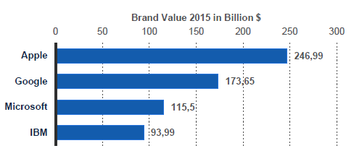

Graph on Brand Values of top companies (in Bn.)

Spending Power – IBM spends loads of money on innovation and maintaining a business position. 1bn$ on IBM Watson, 1.2bn$ on SoftLayer, 1bn$ on IBM Bluemix. IBM company’s sizable spending power is a unique resource that the company must manage responsibly.

**Key Partners:**

IBM Human Ability and Accessibility Centre, a department with the sole purpose of managing IBM’s partners whose goal is to maintain the existing partnerships while finding additional, valuable partners. The purpose is to provide complementary skills and expertise that can result in greater client value. IBM places emphasis on strong partnerships, Ex,

* Twitter – This alliance will let enterprises incorporate Twitter data into decision making, twitter represents an enormous public archive of human thought, IBM’s expertise is in integrating complex systems and data to make a better decision.
* Apple – Redefining the mobile industry by combining the exponential power of corporate data with the world’s best mobile technology. IBM’s MobileFirst for iOS connects users to big data and analytics right on their iOS devices.
* Tencent – Partnership for new cloud software business for corporate customers. Main technology firms are jockeying for a slice of China’s enterprise software market, which promises to grow sharply in the coming years.

**Revenue Streams:**

60% of IBM’s revenues come from its services.

Services: In the form of long-term contracts or changes in terms of output or time.

Software: Perpetual licenses, recurring licenses, or post-contract support.

Hardware: Refers mainly to servers, which can be acquired permanently, on lease or rents.

Financing: IBM facilitates the client’s acquisition of information technology.

IBM is the leader of global IT services. The shift from hardware to software and services has made IBM the world’s market leader in IT services.

**Cost Structure:**

IBM is investing huge amounts into R&D. The majority of spending goes into R&D and marketing, IBM is the only company with higher R&D expenditure than marketing. Due to this, it’s hard to maintain high margins due to the emergence of open source and cloud computing.

**McKinsey: “Cost structure and spending does not correlate to growth”**

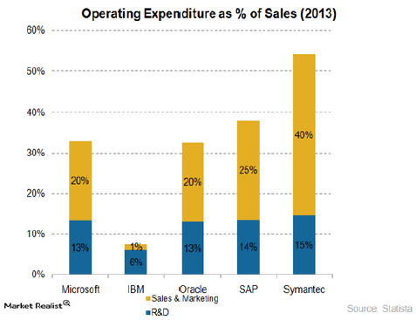

Graph on Expenditure of Sales and Marketing

Knowledge Management in IBM

Knowledge management is the practice of using an organization’s content, social networks, experience, and collective intelligence to increase organizational effectiveness and productivity and to spark innovation and transformation.

IBM's KM strategy consisted of turning the company into a leading knowledge management based company, using technology for sharing knowledge and building the required IT infrastructure. The main objective of the KM framework was to facilitate knowledge sharing and collaboration among employees.

**IBM uses the KM principles to focus on:**

* Federated Search - to bring together content from multiple repositories, including external sources and wikis.
* Sponsored Links - to surface the most important leadership content.
* Expertise Location - to recognize knowledge colleagues on topics across our services and offerings.
* Social Networks - to narrow relevant content, identify influences, key practitioners, and hubs of information.
* Sentiment Analysis - to gauge social media insight on key topics.
* Personalization - to narrow the field of information to just that which is relevant to the individual.
* Rating - to provide peer-ratings and to surface the highest quality content in search results.

**Generating and Sharing Knowledge**

The knowledge generated in IBM could be broadly classified as operational data, knowledge assets, intellectual capital, research & analysis, information obtained from the intranet, and the information available from the Internet. The information was obtained from projects carried out in IBM and the details of projects formed on the basis of knowledge sharing.

**The Benefits**

KM helped IBM in increasing efficiency by the reuse of captured assets and by the transfer of knowledge to improve the skills of employees. It helped the company innovate by bringing in the employees across time and geographic boundaries to share ideas.

Key Knowledge Enablers:

The integration of collaboration and knowledge into portals and the way people learn is IBM’s main focus for improvement. The aim is to optimize the quality and utilization of assets throughout their lifecycle, increase productive uptime and reduce operational costs. Enterprise asset management involves: work management, asset maintenance, planning and scheduling, supply chain management and environmental, health and safety (EHS) initiatives.

Asset Management: The strategy was to provide a knowledge base of the work and of the colleagues so that assets and intellectual capital could be reused, enabling client solutions delivery with better quality and speed.

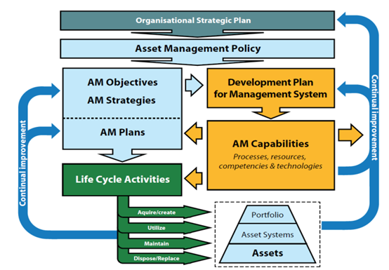

One asset management tool used was **KnowledgeView**.It was made to target IBM’s Business Consulting services and contained a group of repositories that contained key resources and forums to access reusable assets. IBM designed **Xtreme Leverage** in 1999 as a knowledge sharing and collaboration tool aimed for software sellers. The portal maintains intellectual capital, expertise location and facilities for IBM’s global software brands. It is the only place for software sellers to go for content and expertise. It attracts more than 40,000 users with over 400 active communities.

**Expertise Location**: The organization **BluePage** was started by IBM as a corporatewide directory enabled with instant messaging and email linkage. It provides searchable resources for employees looking for experts and networks for collaboration.

**On-demand learning**: These are workplace portals made to focus on critical job roles within IBM to deliver the asset management programs directly to the required audience. These 2 techniques focus on acquiring knowledge through collaborations and networking thus strengthening IBM’s KM resources.

**Supply-chain management:** IBM developed many software products to increase SCM most notably the **Sterling SCM** which included various products:

* Sterling Order Management to coordinate processes.
* Sterling Business Network for companies to see relevant transactions in a single dashboard.

The supply chain network was created to improve key features for the company to remain connected, collaborative, Cyber-aware and Comprehensive.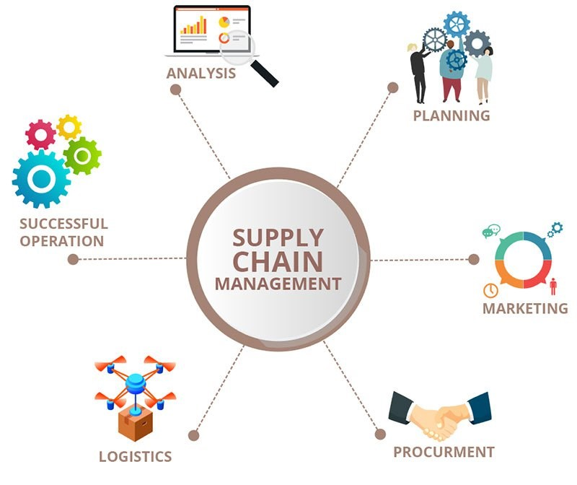

**Joint Ventures:**

IBM has several joint ventures –

* **Maersk and IBM:** JV formed to improve Global Trade and Digitize Supply chains using Blockchain tools.
* **IBM and Vodafone:** JV which was formed to pursue solutions in a variety of developing technology sectors.
* **IBM and Toshiba:** JV formed for Database improvement and specialization.



 



Major Facts that led to the Downfall of IBM



In the 1980’s, IBM’s profit margins experienced a decline. This was attributed to two main factors. Firstly, during this period, IBM became a follower of technological development, more so than in the past. This was an important change because in the 1960’s, IBM led the tech industry with their grand innovation – the 360 series of computers. Also, the company displayed inexperience in its partnering strategies as such left the extremely profitable portions of the market to Intel and Microsoft.

Though these factors are very important, they are not the root causes of IBM’s difficulties. For example, the decline of profit margins was a result of falling customer interest in mainframe computers. That IBM executives failed to foresee this was the result of two more basic factors. First, IBM’s enormous R&D effort of the 1970s should have been directed at the microcomputer, which was about to burst onto the technological scene bringing a future full of personal computers, networks, and computer servers. Instead, the company squandered R&D on building a larger mainframe. Second, IBM shifted its relationships with customers and lost touch with their interests and concerns. Thus, a partial explanation of IBM’s difficulties is that its profit margins on mainframes declined precipitously.

During the 1980’s and early 1990’s, IBM nullified its contracts with both customers and its employees. Although IBM had promised a partnership with its customers, it broke that promise to finance a substantial expansion. IBM broke its promise of security for its employees to bail out stakeholders. Both of these reasons doomed IBM’s business to stagnation in the first half of the 1990’s and left its business prospects uncertain for the remainder of the decade.

When IBM defaulted on its commitments to its customers, they grew angry at its arrogance – for giving them equipment that did not function properly, was delivered late, or did not meet expectations in some way – and its failure to keep up with emerging technologies from other vendors. This caused IBM to lose a large portion of its customers.

When IBM defaulted on its commitments to its employees, many became disillusioned and ineffective. Managers had let thousands believe that employment security had little connection with performance. In attitude surveys, top performing IBM employees complained bitterly that the company’s management was far too tolerant of poor performers. Had managers dismissed ineffective employees at less than half the rate that is common in other computing firms, IBM’s massive financial losses in the 1990s for early retirements and layoffs could have been significantly reduced.

The sequence of events in which IBM executives created the company’s financial disaster in the early 1990s began a decade earlier. In 1980, IBM executives reviewed current trends and made one of the largest miscalculations in business history. They concluded that IBM should continue building itself to support $100 billion in sales by fiscal 1990. This target represented a doubling of then-current revenues but was seen as an “aggressive but achievable” ten-year target for a business then enjoying a recovery from the 1979 “oil shock” recession in mainframe sales, the restoration of margins that had collapsed in the wake of the 4300 pricing fiasco, and the end of computer rentals — a decision that forced customers to buy machines outright.

The then Chairman of Board, John Opel felt that if IBM had the best products and manufacturing, it would win in the marketplace. He saw huge barriers to entry in semiconductor manufacturing in the form of hundreds of millions of dollars for plant and equipment. IBM, with its size and financial strength, would have a big advantage. It could manufacture at low cost through capital investment. It began to see sales and marketing as a necessary evil. IBM, which had been a marketing company, now began its unhappy transformation into something else.

In 1980, IBM’s first published corporate strategy had several key elements: to grow the business, to be the most profitable firm in the industry and to compete where it chose. That none of these items focused on the customer symbolized the company’ s growing hubris. To fund the new capacity, IBM needed more investment. It accelerated its move from rental to sales. The method used by IBM to achieve this adversely impacted their customer relationship.

IBM managers responded to the forecast and related growth plan by hiring tens of thousands of employees and adding billions of dollars in plant and equipment to IBM’s balance sheet. In retrospect, they were wildly optimistic, even negligently so. Building and equipment contractors recall IBM’s lavish spending, which marked a great capacity build-up. In Fishkill, New York, IBM quickly built, at enormous cost, semiconductor plants with the super-clean rooms needed for manufacturing. Two years after they opened, the plants were shut down. In California, laboratories were built at breakneck speed. They were opened, then closed, dismantled, and rebuilt. Mistakes costing tens of millions of dollars were made. To finance such extravagance, IBM accelerated a transition that, over almost two decades, took it from a revenue stream that generated 85 percent by renting (it had been 95 percent) to one of 12 percent renting and 88 percent customer purchases. The company was abandoning the foundation of guaranteed revenue: the rental base.

The strategic plan in 1980 led IBM up a hill of additional capacity and down again. First, it spent money to build capacity and add people; then it spent money to dismantle capacity and shed people. This dynamic was the source of the huge financial write-offs that crushed the firm’s profitability in the early 1990s.

A major forecasting error can seriously cripple a company — especially a company that attempts to provide lifetime employment. Growth planning is normally done cautiously and deliberately, a process that seems to have failed at IBM. As IBM built capacity, it promised investors great returns. Instead, they got losses and a collapsing share price. It’s no wonder that, by the early 1990s, investor analysts believed that the company’s executives had lied to them. Wall Street ceased to listen to the company’s management, and IBM’s executives entered a black hole in which nothing they could say would favorably affect the company’s fortunes.

Solutions IBM Should Have Implemented

Customer Needs:

A company should always primarily focus on the customer needs and its problem first rather than a continuous R&D to invent new things. Even though the new inventions are pioneering, unless there is customer need, it is of no use. IBM should have first concentrated on the microcomputer production rather building new mainframe technologies

Customer Relations:

IBM should have given much focus in solving genuine customer problems which would grab more customers. IBM should have known that customers expect quality reliable products and the value for what they pay for. Fulfilling this criteria builds a healthy relationship with the customer segments.

Efficient Employees :

IBM should have checked the efficiency of the employees and knocking off inefficient employees and appointing dedicated and smart people for work

New Technologies:

A big company like IBM should always stay updated with newer technologies. Using outdated techniques might lose customers' interest in the company.

Business Expansion Strategies:

Finance is the backbone of a company and funds must be released after a very careful analysis of any expansion strategy. While expanding a business it is very important to have discussions and predictions of the later consequences and then design a strategy. IBM should have appointed a better team for advising and guiding its expansion instead of lavishly spending a lot of budget without knowing the later consequence. A foolproof plan should always be there before thinking of business expansion.

Comeback of IBM



During the early 90’s, IBM was rapidly losing its market shares in most markets and the management was planning to break the organization into individual businesses. Soon after the appointment of Louis Gerstner as CEO of IBM in April 1998, he identified the unique competitive advantage of IBM was due its scale and broad-based capabilities and therefore advocated to keep the company together which would help IBM keep this advantage in positioning itself uniquely as a software integrator. Gerstner was responsible for shifting the mental mode of the employees from self-centric to customer-centric, which was one of the main reasons for the fall of IBM.

Gerstner analyzed and came to the conclusion that mainframes, that accounted for 90% of IBM’s revenue, were indispensable for businesses like airlines are credit cards. He concluded that it was the price and not the product that really mattered to the customers. Hence, he suggested a price reduction plan for its customers. Gerstner realized that IBM had a unique and expert capability to “genuine problem solving, the ability to apply complex technologies to solve business challenges and integration.” These sustainable value propositions enabled Lou Gerstner to bring IBM back from the verge of near extinction. Gerstner realized that a difficult, painful and massive reengineering effort was required to get IBM to dedicate resources in bringing value to the customer in the competitive marketplace. Gerstner developed the theme of the “new” IBM. Gerstner identified four major strategies for the recovery of IBM:

Keep the company together – This strategy was implemented in order to help IBM to utilize its competitive advantage (resulting from its scale) and offer integration services to clients.

Change the fundamental economic model – This strategy started by comparing expense-to-revenue of IBM with its competitors. This led to a massive program for expense reduction.

Re-engineer how business was done – Gerstner saw that IBM processes were cumbersome, highly expensive and redundant. He introduced a re-engineering initiative which drastically reduced IBM’s overhead expenses.

Sell underproductive assets in order to raise cash – Under this strategic objective, IBM sold off unproductive assets to raise cash.

ṣIn September 1993, Gerstner eight principles which defined the priorities of the “new” IBM. They are as follows:

* The marketplace is the driving behind everything we do
* At our core, we are a technology company with an overriding commitment to quality
* Our primary measures of success are customer satisfaction and shareholder value
* We operate as an entrepreneurial organization with a minimum of bureaucracy and a never ending focus on productivity.
* We never lose sight of our strategic vision
* We think and act with a sense of urgency
* Outstanding, dedicated people make it all happen, particularly when they work together as a team
* We are sensitive to the needs of all employees and to the community in which we operate.

Lou Gerstner was a pragmatic leader who took action based on good quality information and who showed great respect for the collective knowledge that existed in an organization on the brink of collapse. Lou Gerstner made the firm decision to keep IBM intact, and he changed its fundamental economic model, re-engineered how the company did business, and sold the under-productive assets. He focused on customers–and he used his ability to drive the focus into the employees by holding the leadership and management accountable. And these steps helped IBM turn around and rise above all the expectations. In his 9 years at the helm, the company had grown by around 40% with the majority of the growth coming from the services and consulting division. Also, the stock price of the company during that period increased by 8 times. He had laid a vision on what should be the focus areas for the company in the future. Lou Grestner will always be remembered as the architect of one of the world’s most successful corporate turnaround stories.

Conclusion

* Through the BMC model of IBM we can see that IBM is branched into many sectors of the economy providing various services to each sector. It mainly focuses on software and business while not making much profit in hardware during the recent years.
* IBM’s brand value and its great spending power, mainly in R&D along with the care it has for its customers and its partnership with the large companies of each sector is IBM’s greatest strength and the reason it is where it is today.

References

* [*Business Model Canvas Reference*](https://www.slideshare.net/FranciscoPacheco33/ibm-64538765)